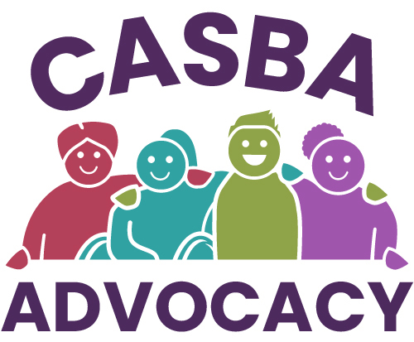

CASBA Application form
Application for employment as: Programme Manager

Application NO: …............ (for office use only)

- Applicants Personal Details
Name

Address

Postcode

Phone

Email

- Education and training
Please list details (start with most recent)
School/College/University | Dates attended | Qualifications received | Date Qualifications received
(Please add to this table if required)

- Most recent employment history
Dates of most recent or present employment | Name and Address of Employer | Job title | Duties | Reason for Leaving

- Previous Employment
Please tell us about other jobs you have done. Starting with your most recent.
Start Date | End Date | Employer | Job Title | Reason for leaving

- Please tell us, using no more than 2 sides of A4 (in Arial 12 font), why you applied for this job, what skills and qualities you will bring to CASBA, and why you think you are the best person for the job.

- Do you consider yourself to have a disability? YES / NO
Please tell us if there are any ‘reasonable adjustments’ we can make to assist you in your application or with our recruitment process.

- References
We require references from 2 referees. Please insert their details below.
First Reference |  | Second Reference
Name |  | Name
Address |  | Address
Postcode |  | Postcode
Tel No |  | Tel No
Email |  | Email
Relationship to you? |  | Relationship to you?
Can we contact them before your interview? | YES / NO | Can we contact them before your interview? | YES / NO

- Please tell us if you are available for the interview dates specified at the end of this application form.
YES / NO
If no, please can you briefly explain why?

- When can you start work for us?

- Right to work in the UK- Do you need a work permit to work in the UK?
YES / NO

I confirm that to the best of my knowledge the information I have provided on this form is correct and I accept that providing deliberately false information could result in my dismissal.

Signature................................................ Date …...........................................

Please return this application form by email to jenny.davison@casba.org.uk by 5.00 p.m. on Friday 10th April 2026.

Please Note:
If selected, you will be working with vulnerable adults, and you must be able to undertake and pass an Enhanced DBS check.

CASBA job application form reviewed June 2023

